Antonio Rosado

Prof. Chien

IOOP Section #4

Lab #9

**By submitting this work, I certify that this assignment is my own work, and that I have not copied in part or whole from online sources or plagiarized the work of other students.**

**7.X1**

**7.X2**

**README**

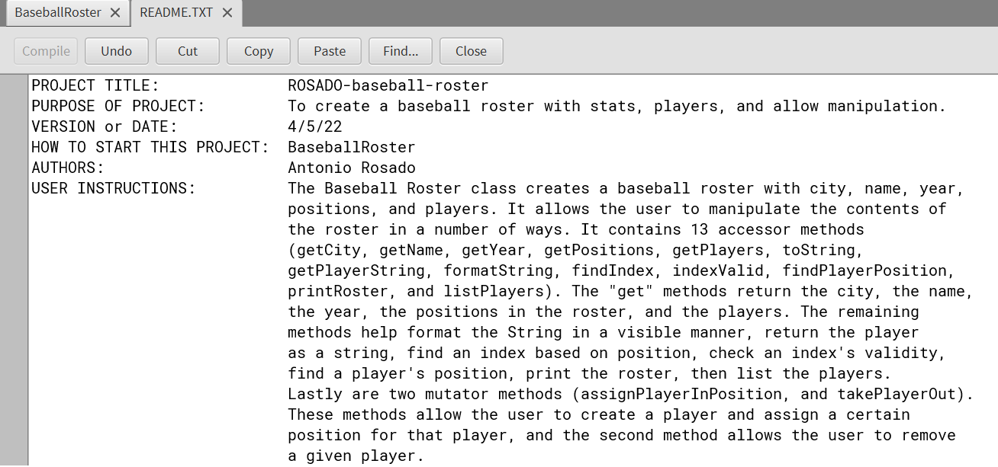

**7.X3**

